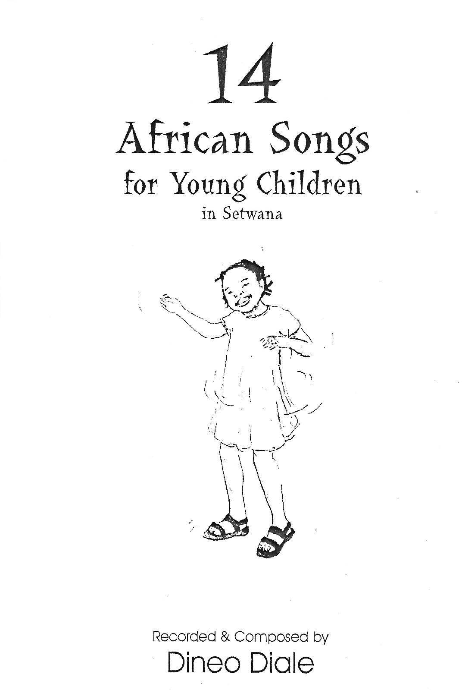

Uittreksel / Extract:

